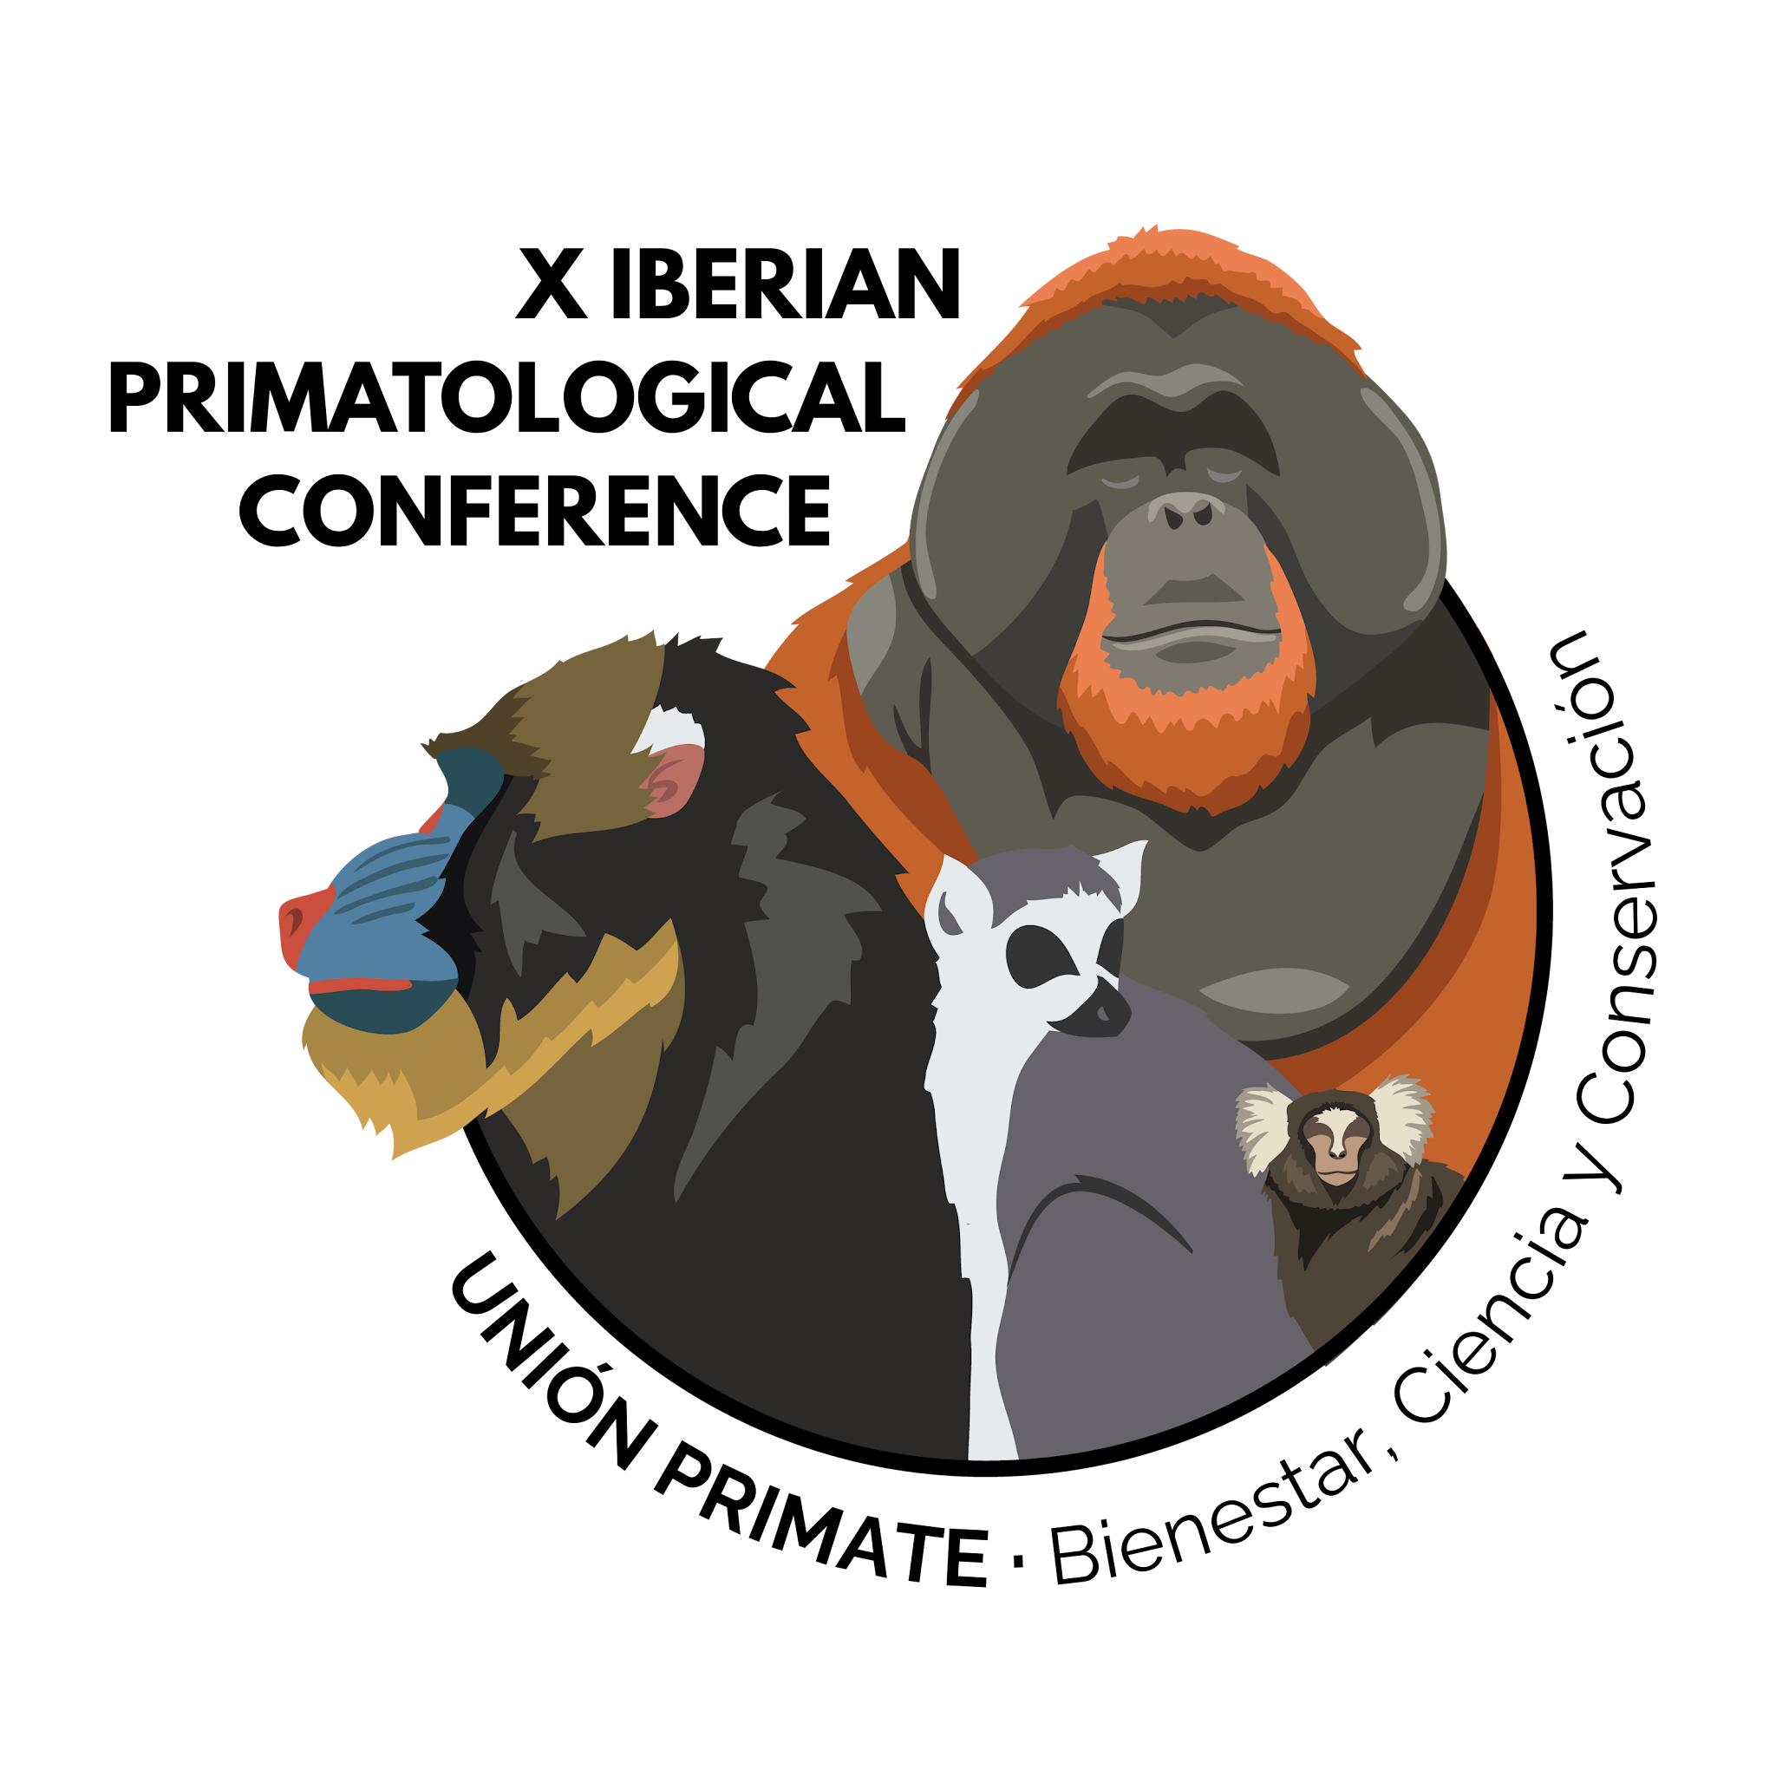

Content: The abstract needs to state the main objectives, location of study, species (including scientific name), sample sizes, methodology, results and conclusions in a single paragraph. Abstracts indicating that «results will be discussed during the presentation» will not be accepted.
Please mark with a cross (x) the preferred type of presentation:
() Oral (X) Poster ( ) No preference

Please mark with a cross (x) if you are a student, researcher, other professional:
() Student, ( ) Researcher, ( ) Other professional

If you are a student please mark with a cross (x) if you want to participate in the Student competition:
() Yes, () No

Title
First author
(Presenting)
Co-author(s)
Affiliation(s)

e-mail of the first (presenting) author
Keywords
Abstract

Contribution to primate welfare and conservation
Please do NOT alter the structure of this document. Simply enter the information following the instructions given as the document will be automatically processed.

After a decision has been made, the Scientific Committee will not engage in any correspondence with submitting authors concerning rejected abstracts or proposals.

Please save this template as a Word Document (yourlastname.doc or .docx) to your computer and email a copy to apespainweb@gmail.com

Once received you will be informed of the successful reception of the submission and will be informed when to expect an email regarding the acceptance status.

